***Karen Zulay Wilson / CMSC- 203***

***Assignment 0***

**Part1 Description GitHub**

**Part 2 Installation JDK RunJava from cmd**

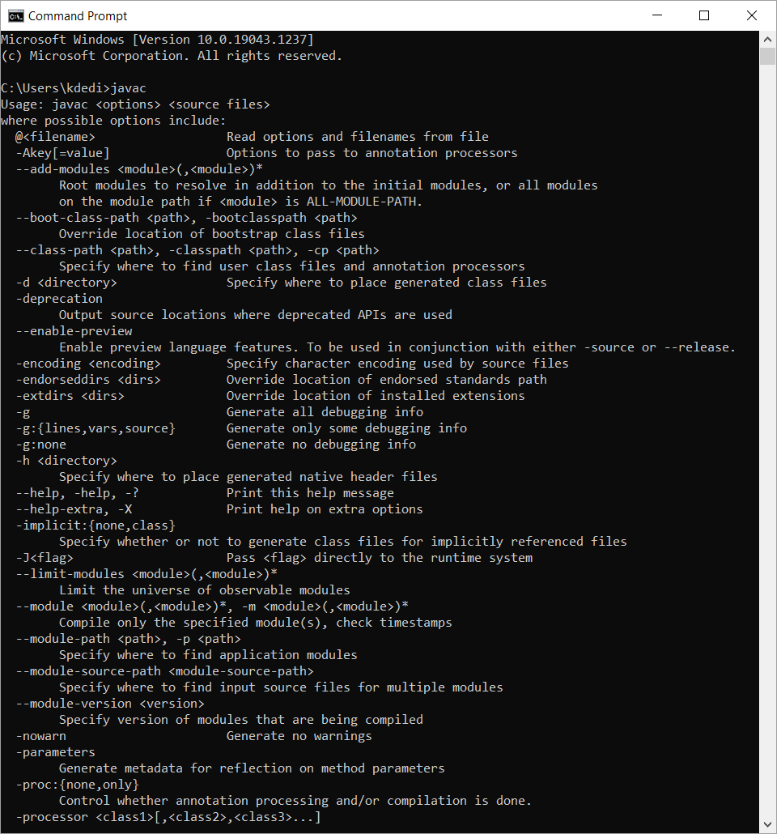

**Step 2**

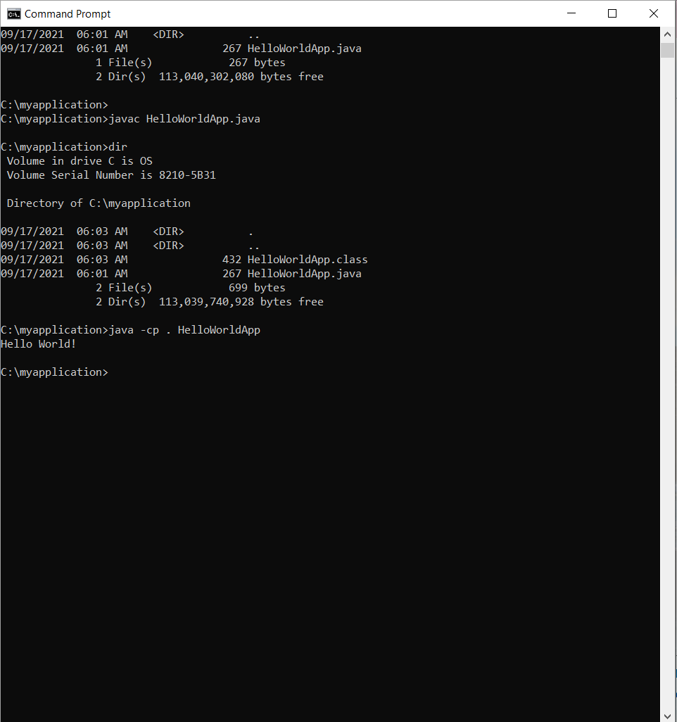

**Part3 Eclipse Installation (1)**

**Step 2**

**Part 4– Setup Junit Test**

